

**Sneaker Online Shop System**

**Software Design Specification**

– Hanoi, April 2023 –

**Record of changeS**

| **Date** | **A* M, D** | **In charge** | **Change Description** |
| --- | --- | --- | --- |
|  |  |  |  |
|  |  |  |  |
|  |  |  |  |
|  |  |  |  |
|  |  |  |  |
|  |  |  |  |
|  |  |  |  |
|  |  |  |  |
|  |  |  |  |
|  |  |  |  |
|  |  |  |  |
|  |  |  |  |
|  |  |  |  |

*A - Added M - Modified D - Deleted

**Table of Contents**

I. Overview 4

1. Code Packages 4

2. Database Design 4

a. Database Schema 4

b. Table Description 4

II. Code Designs 5

1. Login 5

a. Class Diagram 5

b. Class Specifications 5

c. Sequence Diagram(s) 5

d. Database queries 6

2. <Feature/Function Name2> 6

# I. Overview

## 1. Code Packages

***Package descriptions***

## 2. Database Design

### a. Database Schema

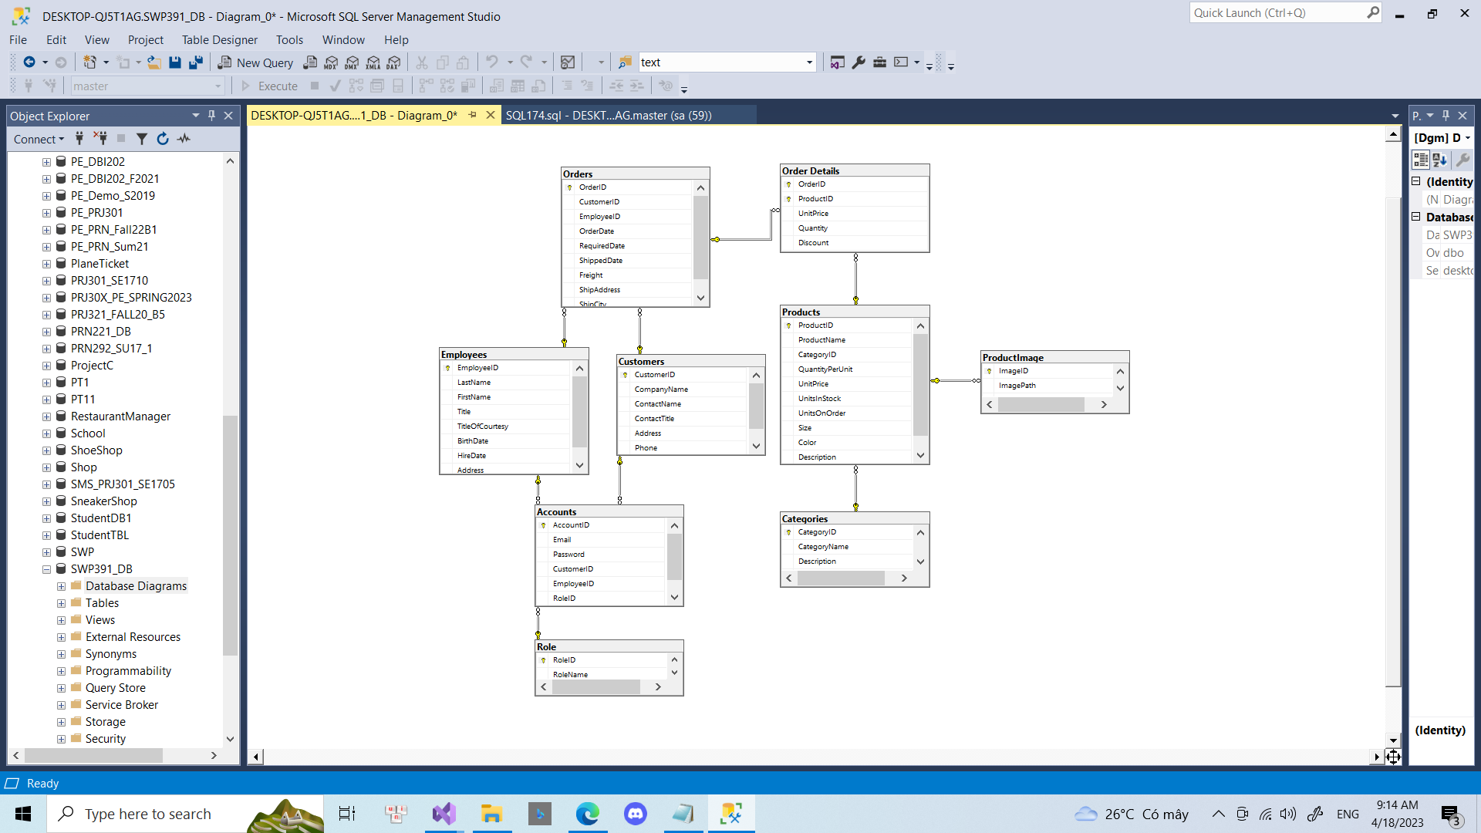

### b. Table Description

#### 

| **No** | **Table** | **Description** |
| --- | --- | --- |
| *01* | *Accounts* | *Get value of Accounts* |
| *02* | *Customers* | *Get value of Customers* |
| *03* | *Employees* | *Get value of Employees* |
| *04* | *Role* | *Contain role of admin/employee/customer* |
| *05* | *Orders* | *Get value of Order* |
| *06* | *ProductImage* | *Contain url of image of product* |
| *07* | *Products* | *Get value of Products* |
| *08* | *Order Details* | *Contain details value of a order* |
| *09* | *Categories* | *Get value of Categories* |

# II. Code Designs

## 1. Login

### a. Class Diagram

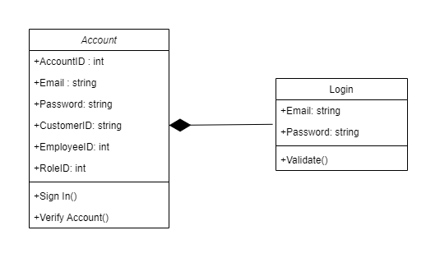

### b. Class Specifications

#### Account

| **No** | **Method** | **Description** |
| --- | --- | --- |
| *01* | *getter/setter* | *Get value of private attributes* |
|  |  |  |

### c. Sequence Diagram(s)

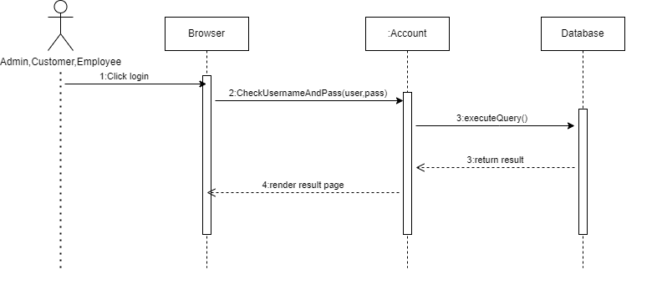

### d. Database Queries

await dBContext.Accounts.Where(

a => a.Email.Equals(account.Email) && a.Password.Equals(account.Password)).SingleOrDefaultAsync()

## 2. Sign up

### a. Class Diagram

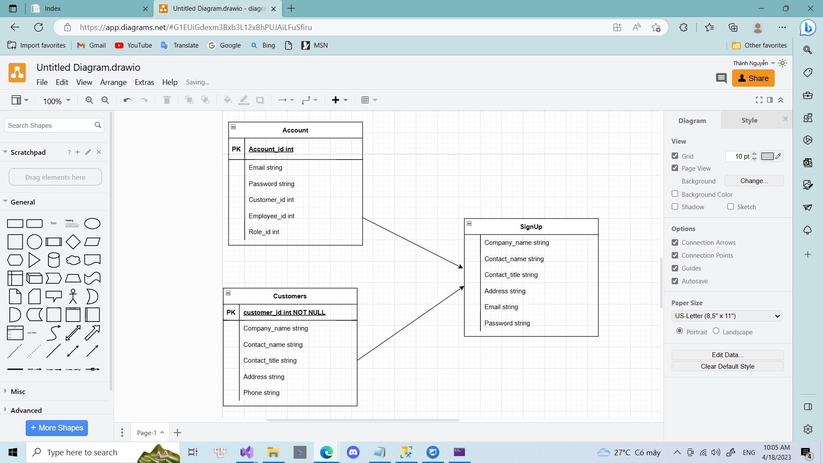

### b. Class Specifications

#### Account

| **No** | **Method** | **Description** |
| --- | --- | --- |
| *01* | *getter/setter* | *Get value of private attributes* |
|  |  |  |

### c. Sequence Diagram(s)

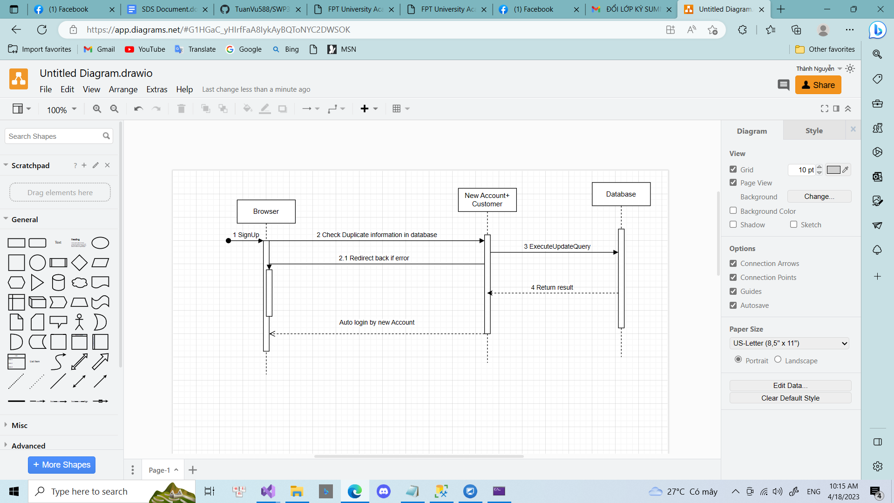

### d. Database Queries

await dBContext.Accounts.SingleOrDefaultAsync(a => a.Email.Equals(Account.Email));

await dBContext.Customers.Where(c => c.CustomerId.Equals(cusId)).FirstOrDefaultAsync();

## 3. Order

### a. Class Diagram

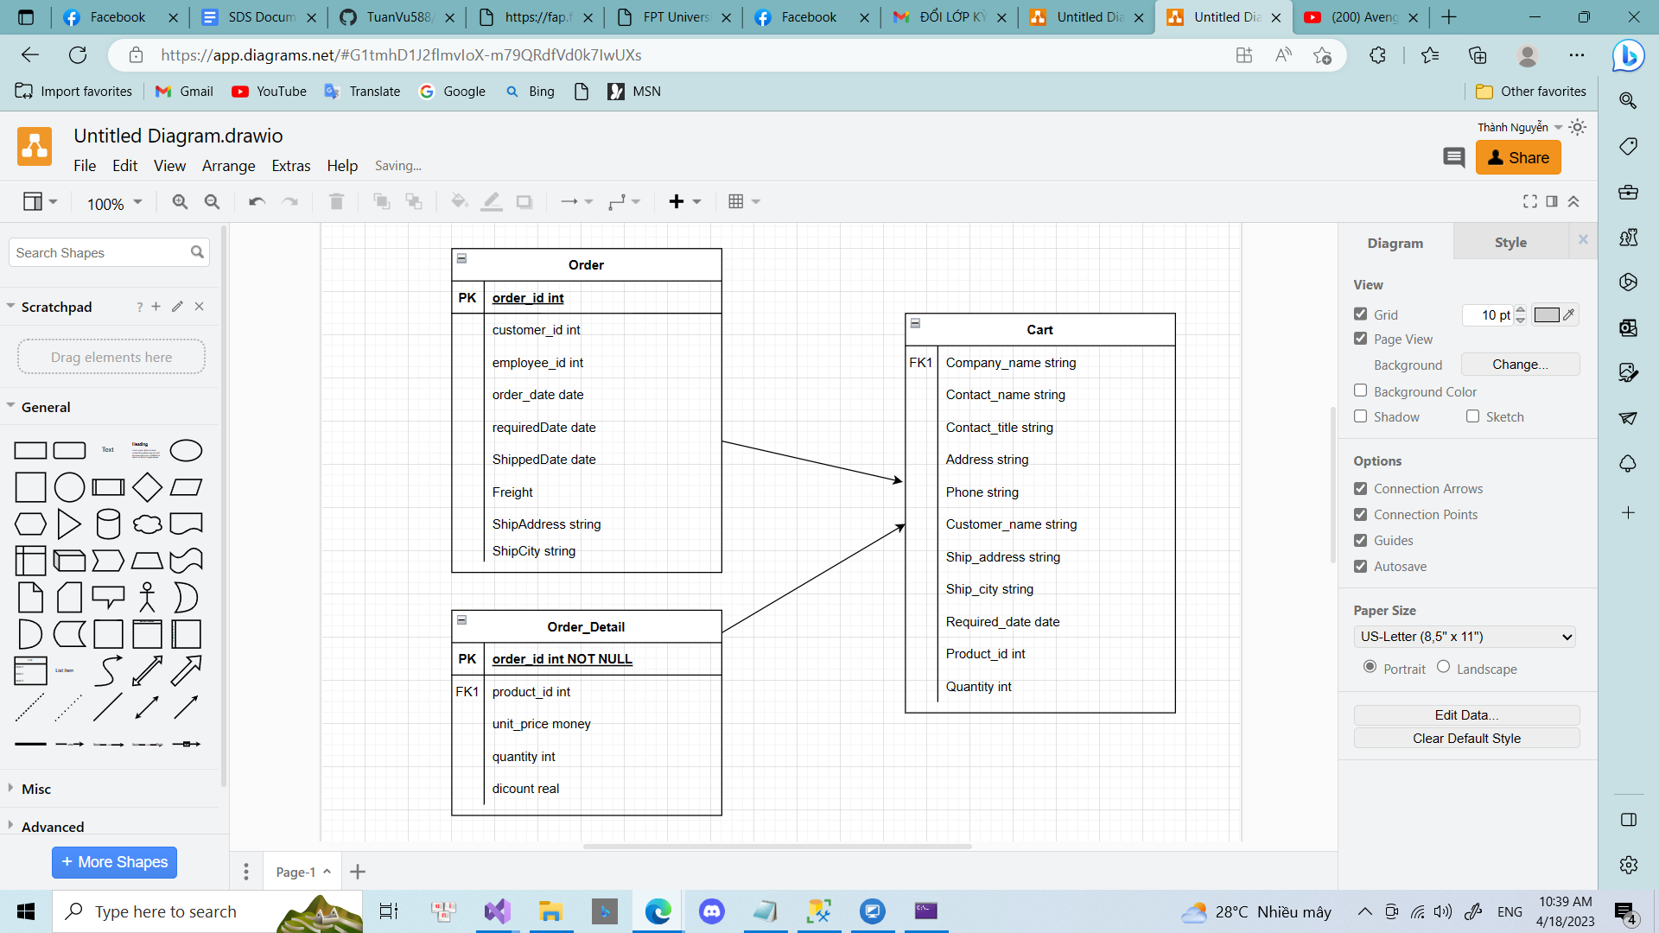

### b. Class Specifications

#### Account

| **No** | **Method** | **Description** |
| --- | --- | --- |
| *01* | *getter/setter* | *Get value of private attributes* |
|  |  |  |

### c. Sequence Diagram(s)

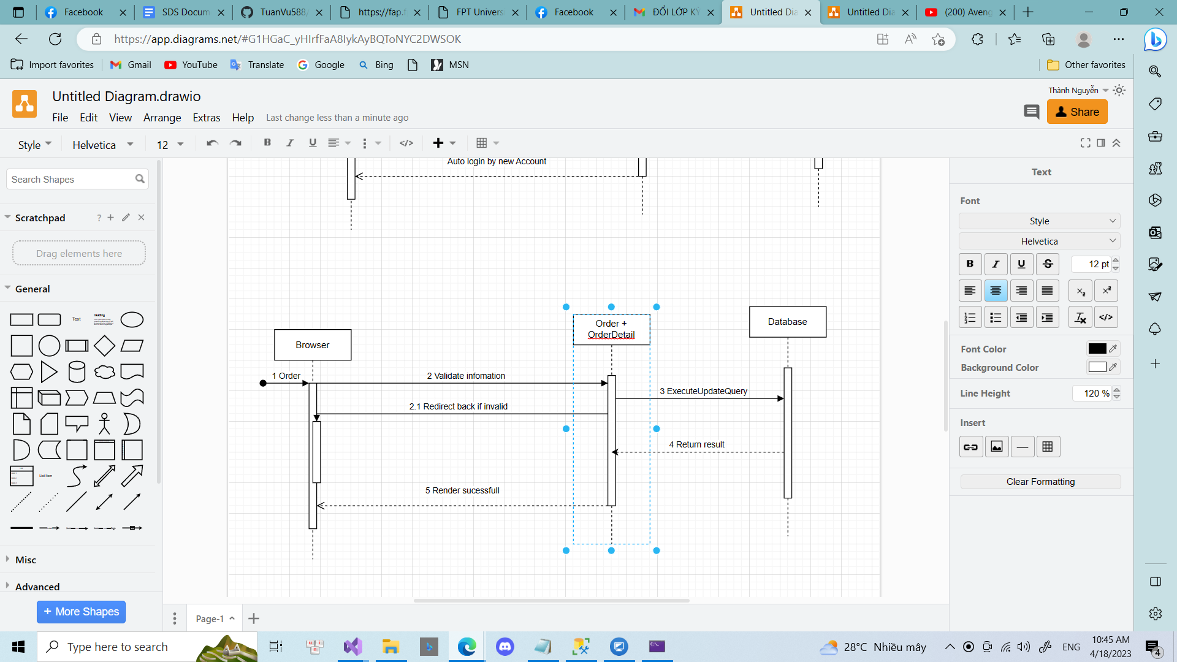

### d. Database Queries

_dbContext.Customers.SingleOrDefault(cus => cus.CustomerId.Equals(Customer.CustomerId));